GEORGEINN
NEWSJAN20
Looking back….. Running a pub these days, is not easy. Many have had to close. There is a lot against us at the George Inn, being isolated in the middle of the countryside, on a fast road!

Despite this, 2019 was a good year. We were delighted to welcome new neighbours, friends from the locality, and people from Kent more widely.

We also welcomed visitors from other parts of the UK along with tourists from the USA, Australia and from many parts of Europe.
We had our first stopovers in the summer. Two impressive campervans arrived. The occupants enjoyed a meal in the restaurant and then a good night’s sleep before continuing their travels.

We feel blessed to be able to share in the lives of so many people, if only for a short while, as they stop for a meal or a drink with us. We are delighted if they share their experience on Trip Advisor or Facebook, and say they will return.

Looking forward……. Our live music nights continue with jazz every Thursday night. A different band plays each week.
Acoustic night, on the third
Wednesday of each month,
covers a range of genres, with
vocals and instrumental music..
Just turn up and join in or sit
back and enjoy!
Folk musicians play together on the first Sunday night of the month and are happy to share their talents with an audience.
We are privileged to be able to enjoy so much original talent in our local area, and for free!

Our menus continue to develop as we try to tempt customers with locally sourced food and also respond to changes people are making in their diets.

Have a look at our new Supper Club Menu – can we tempt you to join us?
See you again, soon.
Michael
GEORGEINN
SUPPERCLUB

Our Supper Club meetings
in 2020 will take place on the first Wednesday in the month. Everyone is welcome but you do need to BOOK YOUR PLACE!

Date of Next Meeting:
Wednesday 5th February
Time:
7pm for 7.30pm
Price:
£22 per person

THIS MONTH’S MENU
Spicy Crab Cakes
Breaded spicy crab cakes, deep fried and served on a bed of lettuce and accompanied by a sweet chilli sauce

Steak and Ale Pudding
Tender Steak and Local Ale combined for this traditional dish
Served with
boiled or mashed potatoes
and
a selection of locally grown, seasonal vegetables

Eve’s Pudding
A light sponge, topped with sliced Kentish Bramley apples and served with custard

All washed down with a glass of warmed
mulled wine

Try our new menus Enjoy a night out with friends Meet new people Keep in touch with friends and neighbours Enjoy the warmth of our cosy fire
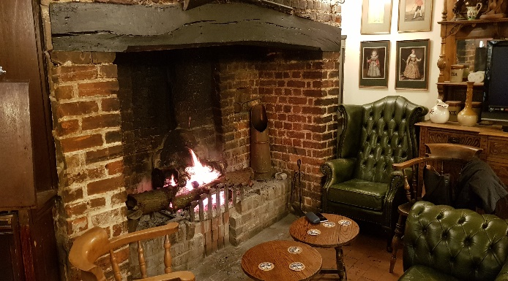

TO BOOK YOUR PLACE
Phone Michael: 01227709170
Or E-mail: landlord@thegeorgeonstonestreet.co.uk
and
Go to: www.thegeorgeonstonesreet.co.uk to subscribe to our Newsletter and keep up to date with our events.

