GEORGEINN
NEWSMAR20
Hello again.
Recently I came across an old, yellowing copy of particulars for a sale that took place at The Royal Fountain Hotel in Canterbury on 5th July 1919.

The sale included ‘23 Excellent Small Holdings and Grazing Farms, 14 of which have a good house and nice buildings’ – the whole extended to 1,060 acres.
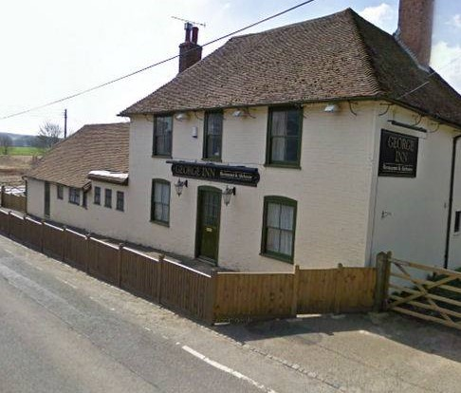
Lot 7 was ‘The George’ Inn and Farm. One hundred years ago, the farm, comprising nearly 60 acres, was described as being ‘in excellent heart’.

It had a half mile frontage, productive arable land and rich pasture with an ‘unfailing’ pond assuring a good supply of water for stock. Outbuildings housed bullocks, cows, pigs, five horses, a granary, a loose box and a cart lodge.

The Inn was listed as ‘a free house, fully licensed and substantially built of brick and tile’. It had a cellar, bar, bar parlour, tap-room, club-room, kitchen, dairy and pantry. There was a large landing and three large bedrooms.
There was also a brick and tile coal house, wash room and WC.
The Inn was described as ‘doing a good trade’.

A tithe was payable to the Parish of Elmstead of 15 pounds, 7 shillings and 5 pence. This included a land tax of 3 pounds, 5 shillings and 11 pence.

Scribbled in pencil on the back of the Sale Particulars, someone had noted the amounts gained for each lot. Lot 7 achieved £1700 and was acquired by Mackesons! ....and the rest, they say, is history!

Do look at our April Supper Club Menu – can we tempt you to join us?
Michael
GEORGEINN
SUPPERCLUB

Date of Next Meeting:
Wednesday 1st April
Time:
7pm for 7.30pm
Price:
£23.50 per person
____________________
Everyone is welcome
but you do need to
BOOK YOUR PLACE
by
Wednesday 25th March
_____________________

THIS MONTH’S MENU
Chicken Liver Parfait
Smooth chicken livers
Seasoned with
brandy and red wine,
Served with warmed French bread
Braised Shoulder of
Kentish Lamb
Locally reared lamb, cooked slowly to bring out the delicate flavour
Accompanied by a port wine sauce, redcurrant jelly and mint sauce
Served with roasted potatoes
and a selection of
locally grown, Spring vegetables
Canterbury Tart
A traditional local dessert:
A pastry case, filled with apple and lemon flavoured custard
Topped with
dessert apples and sugar
Served warm with custard
And our red wine
Easter Cocktail
Try our new menus Enjoy a good night out Meet new people Keep in touch with friends Catch up with the neighbours Enjoy the cosy warmth of our huge log fire
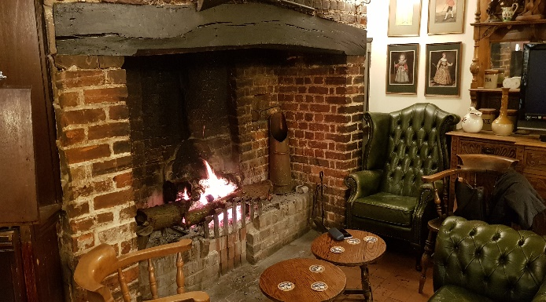

TO BOOK YOUR PLACE
Phone Michael: 01227709170
Or E-mail: landlord@thegeorgeonstonestreet.co.uk
Go to: www.thegeorgeonstonesreet.co.uk to subscribe to our Newsletter and keep up to date with our events.
_________________________

