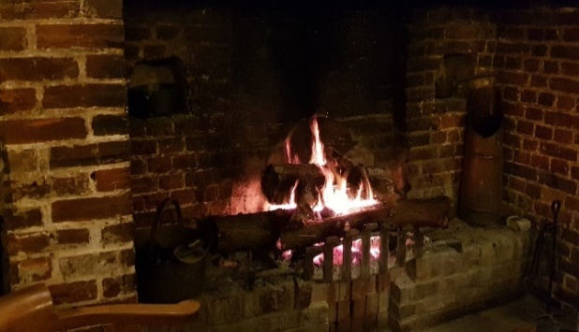
GEORGEINN
NEWSNOV
DEC2019
Hello, again.
Our wonderful inglenook fireplace had a visit from the chimney sweep in November. A roaring fire is such an attraction, with these damp, cold evenings and we want to be sure it is safe.

Max, our local tree surgeon, brings us the fruits of his labours – a great assortment of different woods in all shapes and sizes. It takes considerable muscle just bringing them in from outside and then it needs a lot of creativity to build the fire!

We had a good blaze going last week. One of our regular customers took some great photographs of it as inspiration for her creative writing.

Supper Club: The first of our new Supper Club evenings took place on 27th of last month. Richard, our chef, designed a special three course Kentish menu to include watercress and samphire soup, a roast of Venison and Wild Boar, and Gypsy tart -all washed down with a mug of Kentish cider. We all agreed it was a very special meal!
We hope to make it a regular event so look out for the next one – planned for the New Year – on the first Wednesday in the month. So, Wednesday 5th February is the date for your new 2020 diary!
One of the frustrations of the last two months has been the 4-way
traffic light system in place on Stone Street, at the Stelling Minnis junction. It has caused significant delays to daily journeys and includes a number of overnight road closures. This will go on right through to early December. We hope customers will still find their way to us!
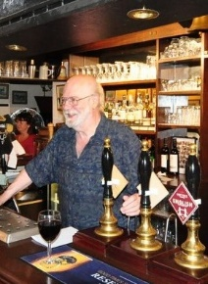
Christmas Menus: On a more positive note, our Christmas menus have received an appreciative response. Bookings are coming in for festive meals, for parties and for Christmas Day lunch. Don’t leave it too late to book! Menus and booking forms are on our website or just give me a call.
Hope to see you again, soon! Michael

Christmas Time
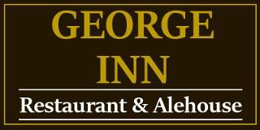
2019

Tel 01227 709170
landlord@thegeorgeonstonestreet.co.uk
www.thegeorgeonstonestreet.co.uk

BOOK NOW!

We
have
some great
menus and
events
CHRISTMAS PARTIES

4 Courses £25 per person

or
4 Courses £28.50 per person ______________________
Christmas Day Menu
5 Courses £85 per person
and don’t forget …….
on Boxing Day
we are serving
‘Brunch ‘
We
have
some very
special
dishes

….as well as the traditional turkey and Christmas pudding…..

Roast Loin of Wild Boar: Local wild boar served with a rich port wine sauce and apple sauce (g)
Nut and Cranberry Loaf: A variety of nuts and fresh cranberries combined and served with a wild mushroom and cream sauce (v)(g)(vg)
Herb Topped Hake: Fresh Hake, topped with fresh herbs and breadcrumbs, baked and served on a chive sauce
Hazelnut & Bulgur Wheat Bake: served with a cream and white wine sauce (v)(vg) ………………and more besides….
BOOK NOW!

